­

Object Oriented Design and Programming-1

Assignment-1

ROLL:2054901052

NAME: MD. FARHAD JAMAN

SECTION-A

DATE:05-11-2020

Bangladesh University of Professionals

QUESTION 1.

CODE:

#include<iostream>

#include<string>

using namespace std;

class Entity

{

public:

virtual string GetName(){ return "Entity";}

};

class player :public Entity

{

private:

string m_name;

public:

player(const string& name)

: m_name(name){}

string GetName(){ return m_name;}

};

void show(Entity* p)

{

cout<<p->GetName()<<endl;;

}

int main()

{

Entity* e=new Entity();

player* p=new player("Farhad");

show(e);

show(p);

}

Answer Screenshot:

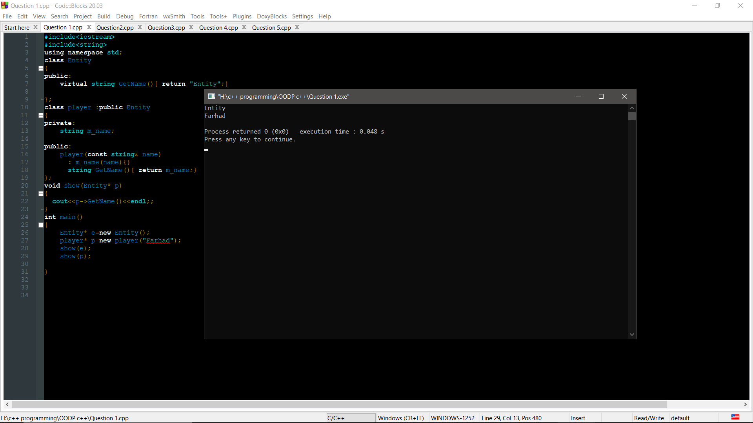

QUESTION 2.

CODE:

#include<iostream>

using namespace std;

#define rep(i,n) for(int i=0;i<n;i++)

class first

{ int book_no;

string book_name;

public:

void getdata()

{

cout<<"Enter the Book name : ";

cin>>book_name;

cout<<"Enter the Book No : ";

cin>>book_no;

}

void putdata()

{

cout<<"Book Name is "<<book_name<<endl;

cout<<"Book No is "<<book_no<<endl;

} };

class second{

string author;

string publisher;

public:

void getdata()

{ cout<<"Enter the name of the Aurthor : ";

cin>>author;

cout<<"Enter the name of the publisher : ";

cin>>publisher;

}

void showdata()

{ cout<<"Aurthor's Name : "<<author<<endl;

cout<<"publisher's Name : "<<publisher<<endl; }

};

class third:public first,public second

{ int pageno,pubyear;

public:

void get(){

first::getdata();

second::getdata();

cout<<"Enter Number of pages : ";

cin>>pageno;

cout<<"Enter the publishing Year : ";

cin>>pubyear; }

void show() {

first::putdata();

second::showdata();

cout<<"Number of Pages : "<<pageno<<endl;

cout<<"Publishing Year : "<<pubyear<<endl;

}};

int main()

{ int num;

cout<<"\nEnter the number of books : ";

cin>>num;

third book[num];

rep(i,num)

{

book[i].get();

cout<<endl;

}

cout<<endl;

rep(i,num)

{

book[i].show();

cout<<endl;

}

}

Answer Screenshot:

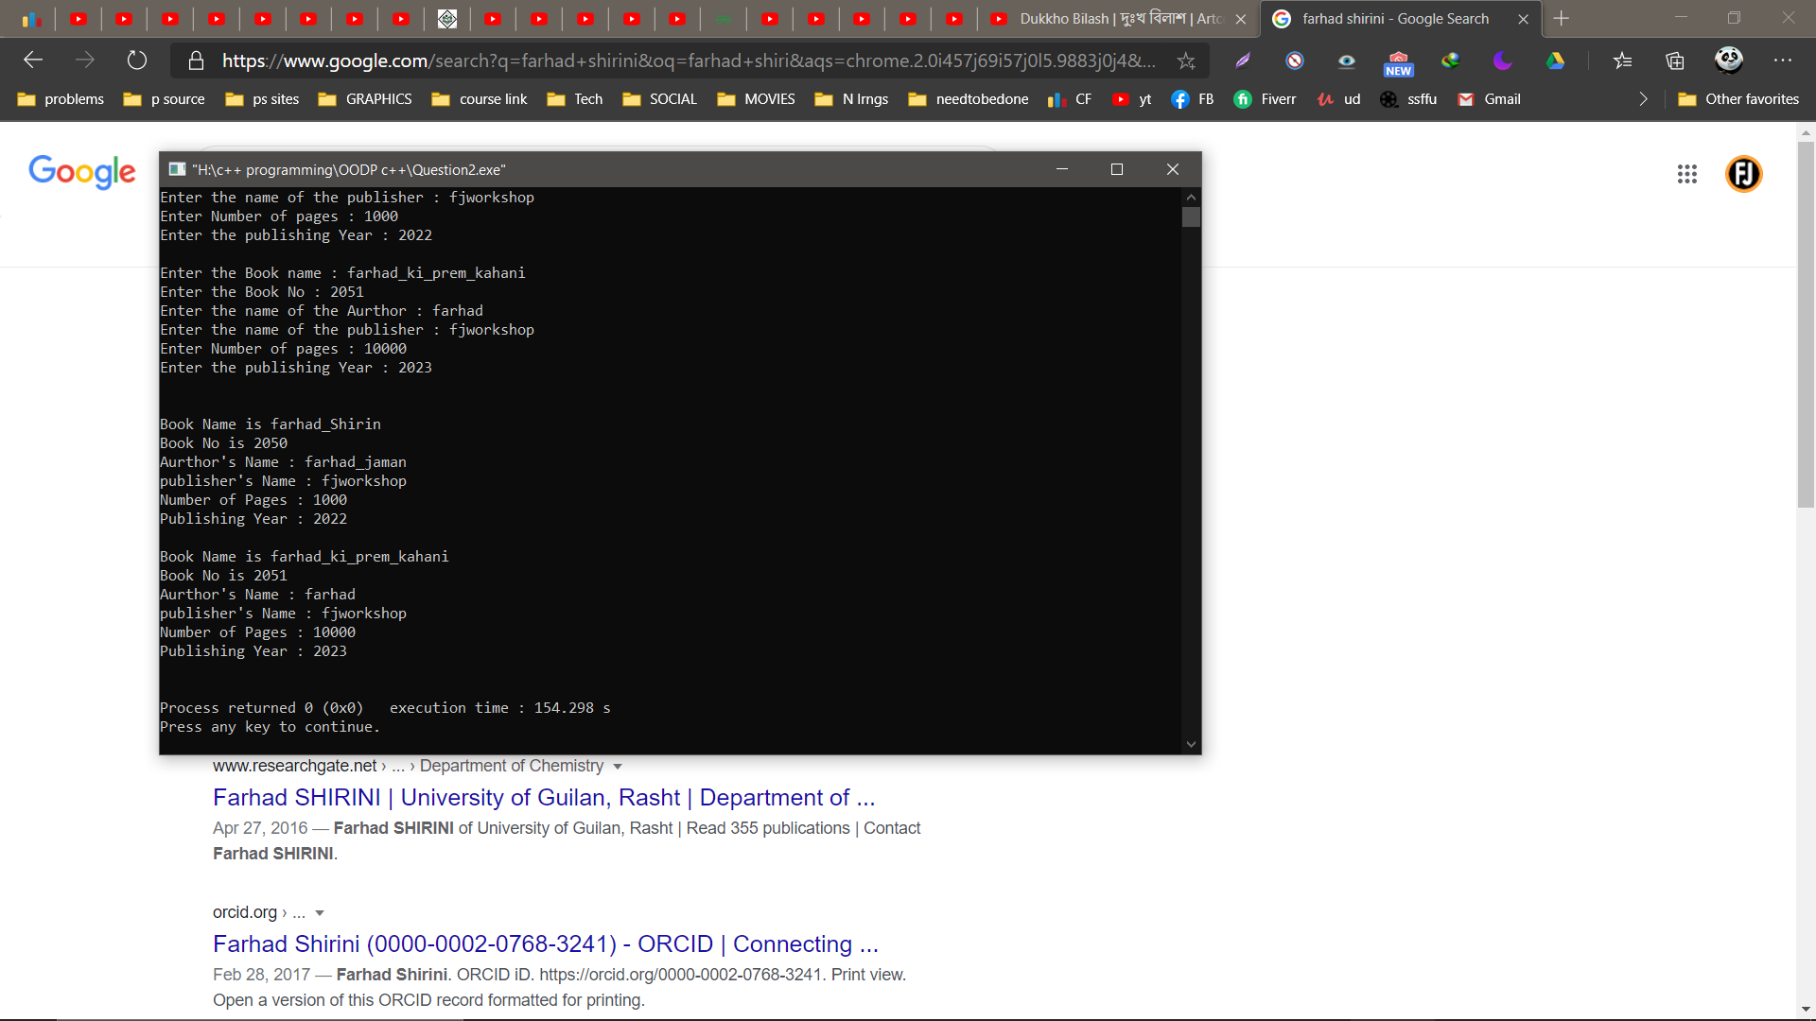

QUESTION 3.

CODE:

#include<iostream>

#include<string.h>

using namespace std;

class A

{

char str[100];

public:

void operator =(char* s1)

{

strcpy(str,s1);

}

void operator +(A obj1) {

strcat(str,obj1.str);

}

void operator <=(A obj) {

if(strcmp(str,obj.str)==0)

cout<<"Both strings are identical."<<endl;

else

{

if(strlen(str)==strlen(obj.str))

cout<<"Strings are not identical but there length is same"<<endl;

else

cout<<"Strings not identical and there length is also different"<<endl;

}

cout<<endl;

}

void display()

{

cout<<str<<endl;

}

};

int main()

{

char str1[100];

char str2[100];

cout<<"Please Enter the first string"<<endl;

cin.getline(str1,100);

cout<<"Please Enter the second string"<<endl;

cin.getline(str2,100);

A s1,s2;

s1=str1;

s2=str2;

cout<<"After String Copy"<<endl;

s1.display();

s2.display();

cout<<endl;

cout<<"String Comparison :"<<endl;

(s1<=s2);

s1+s2;

cout<<"After string concatenation :" ;

s1.display();

}

Answer Screenshot:

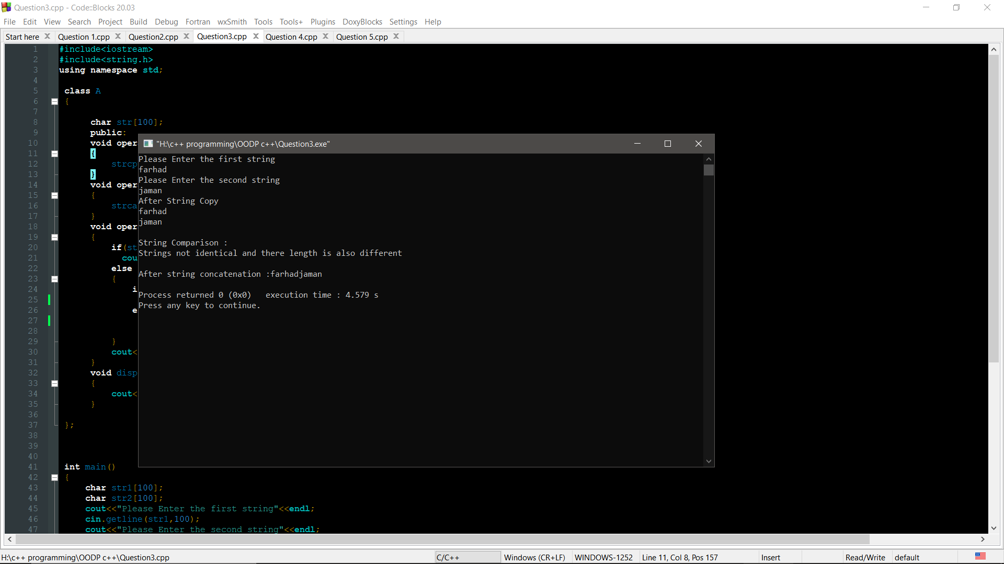

Question 4:

Code:

#include<iostream>

using namespace std;

class TIME

{

int hours,minutes,seconds;

public:

void getdata()

{

cout<<"Input Hours : ";

cin>>hours;

cout<<"Input Minutes : ";

cin>>minutes;

cout<<"Input seconds : ";

cin>>seconds;

}

void add(TIME &s2)

{

this->hours=this->hours+s2.hours;

this->minutes=this->minutes+s2.minutes;

this->seconds=this->seconds+s2.seconds;

}

void display()

{

cout<<"Total Time = ";

cout<<hours<<"hrs"<<" : "<<minutes<<"mins"<<" : "<<seconds<<"secs"<<endl;

}

};

int main()

{

TIME s1;

TIME s2;

s1.getdata();

cout<<endl;

s2.getdata();

s1.add(s2);

cout<<endl;

s1.display();

}

Screenshot:

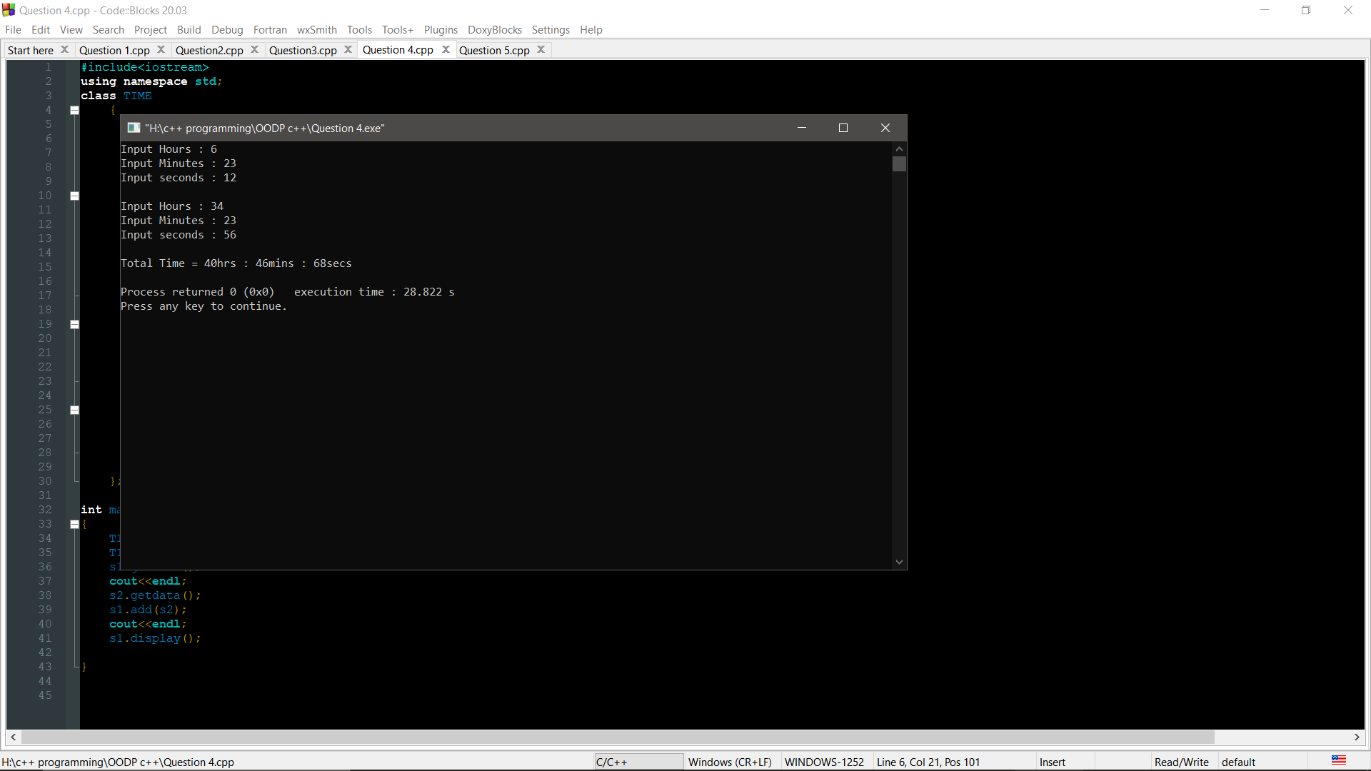

Question-5

Code:

#include<iostream>

using namespace std;

class fibonacchi

{

unsigned long int temp1,temp2,total;

public:

fibonacchi()

{

temp1=0;

temp2=1;

total=temp1+temp2;

}

fibonacchi (fibonacchi &ref1)

{

temp1=ref1.temp1;

temp2=ref1.temp2;

total=ref1.total;

}

void series(int n)

{

cout<<temp1<<" "<<temp2<<" ";

for(int i=0;i<n-2;i++)

{

cout<<total<<" ";

temp1=temp2;

temp2=total;

total=temp1+temp2;

}

}

};

int main ()

{

int n;

cout<<"How many number you want to Print"<<endl;

cin>>n;

fibonacchi number;

number.series(n);

}

Output Screenshot:

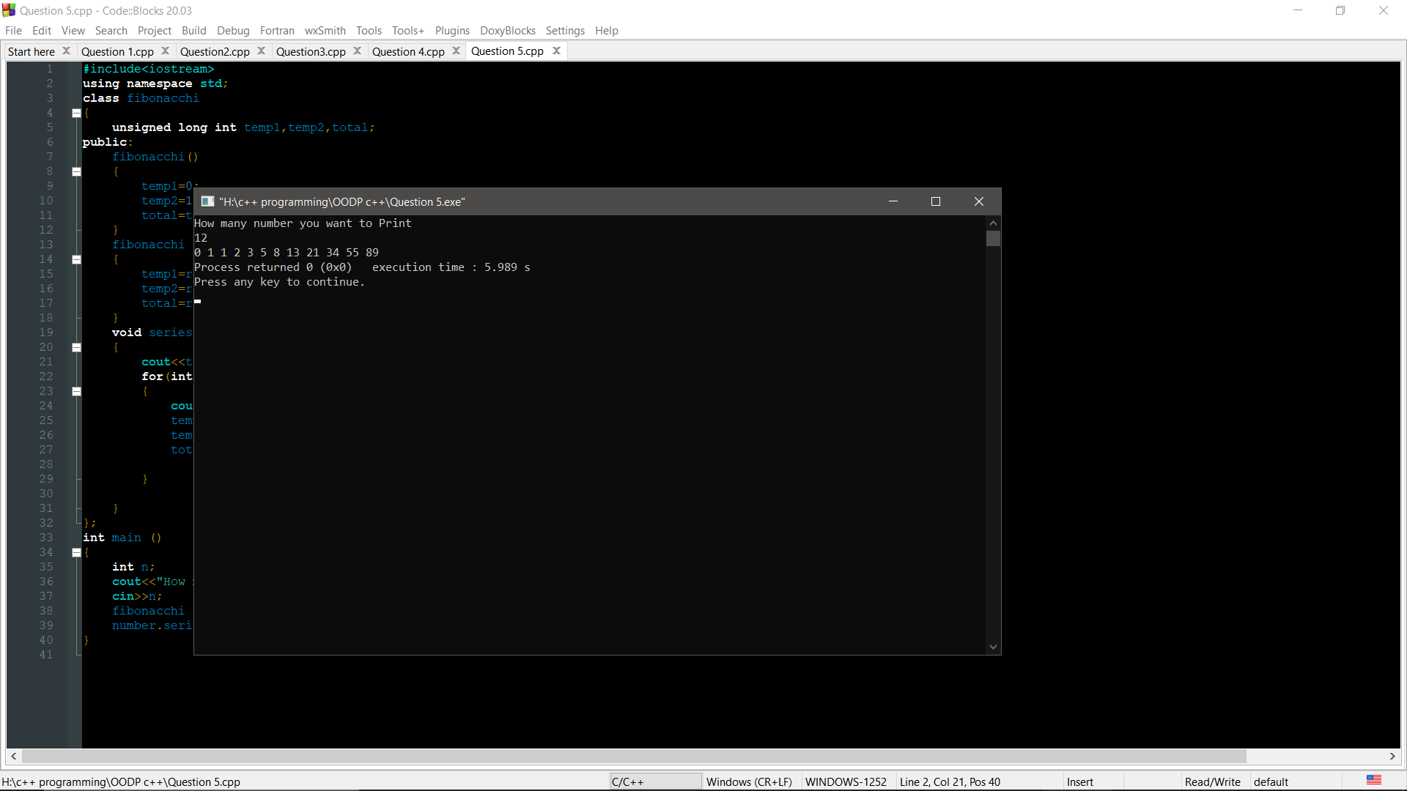

THANK YOU